Metropolitan Washington Council, AFL-CIO
Executive Board Meeting
June 18, 2018

4:30P: Called to Order
Roll Call of Officers: Briscoe, Bunn, Carson, Davis, Flood, Greenhill, Harris, Jeter, Reed, Richardson
Excused: Griffin
Absent: Bast, Clay, Collins, Contreras, Courtien, Desmond, Dyer, Federici, Fields, Griffin, Havard, Ratliff, Renne, Washington
Minutes (May): approved as distributed.
Financial Report: Extensive discussion on the Office Administrative Assistant position posted on 6/18, focusing on the tension between the short-staffing situation at the Council and concerns about hiring FT staff amid financial uncertainty pending impact of Janus decision. It was noted that a discussion also needs to be had over the question of whether the Council will proceed with an Executive Director and a full-time President. It was proposed to hire a temp for the OAA for now, pending a further discussion and/or retreat on the position specifically and the budget overall. Pres. Jeter asked for any changes/suggestions to be sent to her ASAP via email so she can incorporate them into the job description. Liz and Doris – via temp agencies they’ve used in the past -- and perhaps OPEIU 2 may be able to provide candidates.
The financial report was moved and seconded. Question raised on the lease discussion with the AFL-CIO, and for how many years (5). Approved.
Correspondence
$1,000 donation to Poor People’s Campaign and $100 to IBEW 26 Poker Run; moved, seconded and approved.
Post-Janus Report
Liz Davis (WTU 6) and David Dzidzienyo introduced Michael Piccinelli, Senior Associate, Research and Strategic Initiatives at AFT, who drafted a memo on Post-Janus Legislation in the District of Columbia, as agreed in last month’s Executive Board meeting. The memo outlines current law and potential legislation. Piccinelli reviewed the memo; discussion ensued. Event is being planned for 6/29 9:30a-1p at Teamsters 639, for which they would like the Council to turn out affiliates. Details to be provided ASAP for distribution.
6:27P: Adjourned

Metropolitan Washington Council, AFL-CIO
Executive Board: June 18, 2018

Agenda………………………………. page 2
Minutes (May)…………………….. page 3
Correspondence…………………… page 6
COPE…………………………………. page 7
Union Cities………………………… page 10
Financial Reports…………………. page 12
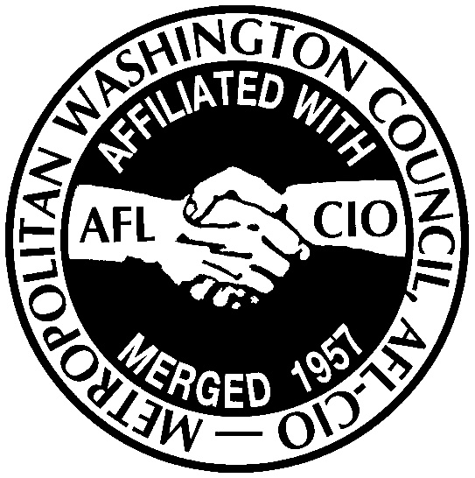

Metropolitan Washington Council, AFL-CIO
Executive Board Meeting
June 18, 2018

4P: Call to Order
Roll Call of Officers
Update on Poor People’s Campaign
Minutes
Correspondence
Financial Report
President’s Report
Organizational Reports:
Union Cities
CSA
COPE/Political and Legislative Campaigns
Board Member Reports
6:30P: Adjourn
Metropolitan Washington Council, AFL-CIO
Executive Board Meeting
May 21, 2018
Called to Order at 4:38pm
Roll Call of Officers:
Present: Jackie Jeter, Gino Renne, Andrew Washington, Carl Carson, Elizabeth Davis, Larry Greenhill Sr., Jim Griffin, Herbert Harris, Doris Reed, Dave Richardson, Cynthia Collins
Excused: Eric Bunn, Dennis Desmond, Jaime Contreras,
Absent: Dena Briscoe, Aaron Bast, Chuck Clay, Stephen Courtien, Dan Dyer, Michael Flood, Don Havard, Mark Federici, Dan Fields, Tommy Ratliff
Also attending: Victoria Leonard (LIUNA); Amir Malek
Staff: Garlock, Dzidzienyo, DuCote
Poor People’s Campaign Update: David Dzidzienyo reported; launched last Monday with event on Capitol Hill; good turnout in general and also by MWC affiliates, who helped swell the ranks, much appreciated by the organizers. Richardson noted that UFCW really turned out, and that the civil disobedience was mostly clergy. June 4 issue is focused on health care, and healthcare locals have committed to turning out. Janus decision/impact is also a major issue of concern. Discussion ensued. Conclusion is that the Metro Washington Council needs to work with affected locals to assemble and disseminate some best practices -- and a letter to the DC mayor --on how local unions can deal with the effects of the Janus decision. Ctte: Washington, Richardson, Carson, Davis; staff: Dzidzienyo. Doris has draft and Liz/Jackie will circulate draft letter for input.
Reading of the Minutes (April)
Moved, seconded and approved.
Correspondence
MD/DC AFL-CIO, 6/15/2018, Salute to Leadership: moved, seconded and approved to take a full-page ad ($500) and a table ($1,500).
IBEW 1900 6/22/2018 Golf Tournament: movced, seconded and approved to sponsor a tee ($100).
Total approved: $2,100
Financial Report: Budget Report
Amir Malek reviewed reports. Bottom line is that the Council’s financial position is $200K stronger than this time last year. Discussion about systemic improvements that have been made in billing/collecting per capita in last two years. President Jeter directed that a letter and follow-up calls be made to those locals with outstanding debts and that a decision be made about how long -- 3 years? -- to carry that on the books. She’s also asked Jo Combs to draft a job description -- temporary to start but intended to be full-time (need to check with NewsGuild on what the CBA says about such a position) -- for a position to cover some of the office work that needs to done for the Metro Council to function effectively. Moved and seconded to receive; approved.

Evening with Labor: Discussion about whether and how -- what format -- to continue this annual event, with concerns about purpose, noise, etc.
President’s Report: Candidate Endorsements
President Jeter thanked the COPE committees for all their hard work on the interview and endorsement process and asked Political Director David Dzidzienyo to share the recommendations (see below).
District of Columbia
2018 Primary Election Candidates
District of Columbia - Mayoral Candidate: No Recommendation
District of Columbia City Council - Chairman Candidate: Phil Mendelson
District of Columbia - Attorney General Candidate: Karl Racine
District of Columbia City Council - At-Large Candidate: Anita Bonds
District of Columbia City Council - Ward 1 Candidate: Brianne Nadeau
District of Columbia City Council - Ward 5 Candidate: Kenyon McDuffie
District of Columbia City Council - Ward 6 Candidate: Charles Allen
It was moved and seconded to accept the recommendations above, except for the Mayor’s race; approved with one dissenting vote. Discussion ensued on the Mayoral endorsement, including the question of how to streamline the Metro Council’s interview and endorsement process. Moved (Renne) and seconded (Harris) to endorse Muriel Bowser for Mayor of DC. Unanimously approved.
Prince George’s/Montgomery County Committee on Political Education (COPE)
Endorsement Recommendations
Montgomery County Council At-Large
2018 Primary Election Candidates
Montgomery County Council At-Large: Charles Barkley
Montgomery County Council At-Large: Brandy Brooks
Montgomery County Council At-Large: Danielle Metiv
Montgomery County Council At-Large: Chris Wilhelm
Discussion ensued: Moved (Harris) and seconded (Washington) to change Barkley endorsement to “No Recommendation”; approved. Moved (Renne) and seconded (Washington) to accept the other recommendations; approved.
Montgomery County Council
2018 Primary Election Candidates
Montgomery County District 001: No Recommendation
Montgomery County District 003: No Recommendation
Montgomery County District 004: No Recommendation
Montgomery County District 005: Tom Hucker
Discussion: Moved (Renne) and seconded (Greenhill) to endorse Nancy Navarro in District 4; approved. Moved (Renne) and seconded (Jeter) to endorse James McGee in District 1; approved. Ben Snyder, District 3 was recommended (above “No Recc” is an error); approved. District 5 Hucker approved.
Prince George’s County Council At-Large
2018 Primary Election Candidates
Prince George’s County Council At-Large: Gerron Levi
Prince George’s County Council At-Large: Karen Toles
Discussion: moved/seconded to accept recommendations; approved.
Prince George’s County Council
2018 Primary Election Candidates
Prince George’s County District 001: No Recommendation
Prince George’s County District 002: No Recommendation
Prince George’s County District 005: No Recommendation
Prince George’s County District 008: No Recommendation
Prince George’s County District 009: No Recommendation
Discussion: Dist 1: Tom Dernoga moved/seconded; Dist 2: Deni Tavaras moved/seconded; approved. Dist 5: Moved and seconded to accept “No Recc”. Dist 8: Moved and seconded to accept “No Recc”. Dist 9: Sidney Harris moved, seconded and approved. Dist 6 and 7: No Recc; moved, seconded and approved.
Prince George’s County Board of Education
2018 Primary Election Candidates
Prince George’s County District 002: Joshua M. Thomas
Prince George’s County District 003: Juwan Blocker
Prince George’s County District 006: Pat Fletcher
Prince George’s County District 009: Arun Puracken
Moved and seconded to accept recc; approved.
Moved, seconded and approved to endorse Cynthia Collins for the PG Democratic Central Ctte At-Large.
Initiative 77 (DC); DC COPE recommends support for this initiative. Moved and seconded to accept recommendation; approved.
Adjourned 7pm
Council Correspondence |  | MONTH: June 2018
Organization/Individual | Event Date | Request/Purpose | Tickets | Ads | Other
Poor People's Campaign | May 14-June 18 | Poor People's Campaign |  |  | $1,000
IBEW 26 | 22-Sep | Poker Run (kids with cancer) |  |  | 250-1000
Total YTD 2018  January  February  March  April  May  June | $ 4,975  $0  $0  $ 2,225  $ 550  $ 2,200

COPE Report
David Dzidzienyo, Director of Political/Legislative Affairs
The Committee on Political Education Department (COPE) has continued to make progress while addressing affiliate concerns, strengthening our infrastructure and building the Council’s political strength and influence. Listed below are some important dates for your review, along with a few important updates.
2018 Political Calendar Important Dates:
- Tuesday, June 19, 2018 – District of Columbia Primary Election
- Tuesday, June 26, 2018 - State of Maryland Primary Election

District of Columbia Committee on Political Education (COPE):
On Tuesday, June 19, 2018 the District of Columbia 2018 Primary Election will be held. We would like to encourage all affiliates to get the word out to their rank and file members. To notify them on which candidates have been endorsed by the Metropolitan Washington Council, AFL-CIO. Getting this information to our members will be critical if labor is truly going to be able to maximize the union density that we have in key areas.
Please see the following below:

- U.S. Congressional Representative – Eleanor Holmes Norton
- District of Columbia Mayor – Muriel Bowser
- District of Columbia City Council Chairman – Phil Mendelson
- District of Columbia - Attorney General – Karl Racine
- District of Columbia City Council - At-Large – Anita Bonds
- District of Columbia City Council - Ward 1 – Brianne Nadeau
- District of Columbia City Council - Ward 5 – Kenyon McDuffie
- District of Columbia City Council - Ward 6 – Charles Allen
- Vote YES on Initiative 77

Affiliate Meetings
We are in the process of scheduling meetings with several District of Columbia City Councilmembers and affiliates to discuss the worker safety laws throughout the various sectors; and how they can be improved upon through possible legislative actions.
Committee Meetings
On Tuesday, June 12, I attended the Transportation Committee meeting that is chaired by Brotherhood of Locomotive Engineers & Trainmen-Chairman / State Representative - District of Columbia, Herbert Harris. The reason for my attendance was to provide an update on the 2018 Primary Electoral races throughout the jurisdiction and to assist with any legislative initiatives that may be decided upon.

Poor People’s Campaign
On Monday, May 11, 2018, I attended the Poor People’s Campaign rally where Dr. William Barber and others spoke about the daily injustices that our society is dealing with. He also discussed how working together, commitment and a strategic approach are key to bringing a resolution to these injustices and criminal actions. The common theme he stressed was accountability. On Friday, May 18, 2018, I participated in the Poor People’s Campaign committee conference call. The purpose of the call was to take an assessment of how successful the May 14th Poor People’s rally was and Also, the meeting was an opportunity to decide what needs to be done moving forward and what responsibilities everyone would be tasked with for the Saturday, June 23rd 2018 Rally.
Legislative Update:
Paid Leave
The Paid Leave Coalition continues to work with the Department of Employment Services (DOES) on the Paid Leave program regulations. We are currently waiting for DOES’s response to our suggested amendments to the regulation guidelines concerning the Paid Leave Program. The coalition wants to ensure that the regulations that are being proposed do not discourage individuals from utilizing the program.
Prince George’s/Montgomery County Committee on Political Education (COPE):
Over the last month, members of the Metropolitan Washington Council, AFL-CIO Committee on Political Education have been volunteering their time in support of various campaigns efforts. Some have volunteered to support the labor to labor efforts in Montgomery County led by UFCW 1994 and others have participated in efforts in Prince George's County. These efforts are truly appreciated. With nine days left before the Maryland State Primary Election. We have a great opportunity to still have a major impact in some of these critical races. An opportunity to build on our political leverage in Prince George's and Montgomery County.

We understand that many affiliates have specific priorities and resources are scarce. But for the next two weeks, we would like to encourage our affiliates to support the labor efforts in Prince George's and Montgomery County. If you have any volunteers that are available during the week from 4pm - 7pm or Saturdays from 10am - 3pm, they can meet us at UFCW 1994 - 600 S. Frederick Ave Suite 200, Gaithersburg MD 20877. We could definitely use the help. If you can't stay the entire time that is ok. Please contact Amy Millar at 240-876-1660, if you are able to assist in Montgomery County.
We would also like to encourage all affiliates to get the word out to their rank and file members. To notify them on which candidates have been endorsed by the Metropolitan Washington Council, AFL-CIO. We provided that information a couple of weeks ago but we will send it out again later today. Getting this information to our members will be critical if labor is truly going to be able to maximize the union density that we have in key areas.

That said, we have also had a few requests from candidates that have been endorsed by the Metro Council. They have asked if we could assist in disseminating their literature on Election Day, June 26th. Please contact David at (202) 320-9027 to coordinate if your local is able to assist in these efforts.

TriCounty Committee on Political Education (COPE):
On Saturday, June 9, 2018, the TriCounty Committee on Political Education volunteers participated in canvassing efforts in Charles County to galvanize support for our endorsed candidates.
On Wednesday April 25, 2018 I attended the funeral of former TriCounty Committee on Political Education (COPE) Chair, the Honorable Bill Grooms. Mr. Grooms was the COPE Chair for over forty years and just recently stepped down from his position. He was instrumental in building our political influence in the TriCounty County area and well respected by all. Mr. Grooms had a profound impact on so many lives he came in contact with. He will be sorely missed by the TriCounty family and all of labor. The TriCounty COPE is currently discussing how we would like to pay tribute to Brother Grooms for the many years of service to the labor movement.

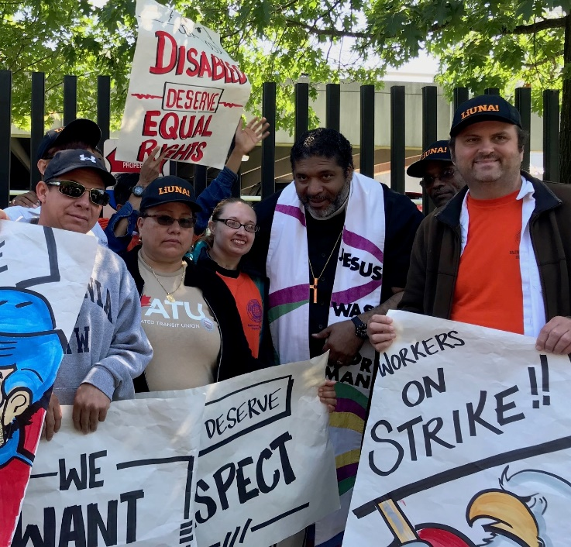
UNION CITIES June 2018 Report
Chris Garlock, Coordinator
Union City database update: Union City subscribers are now at 33,113, after updates to reduce duplicates and bad email addresses. That effort is ongoing and we can expect our overall number to decline as we eliminate more duplicates and bad emails. Going forward, we’ll also be working on plans to recruit new UC subscribers.
Social media: Our Facebook followers are at 1,219, and our page reach over the last month was 1,725, a drop-off from the previous month’s high engagement, driven by the LaborFest. Our Twitter following is up slightly at 4,138 (up from 4,116 last month). Our website traffic in May was 3.5K users, up 3.7% from April.
These communications platforms, plus Union City Radio (WPFW) and Your Rights At Work (WPFW) continue to enable the Council to effectively disseminate local labor news and promote events organized by Council affiliates, as well as other local and national labor events.
DC LaborFest: The just-concluded 2018 DC LaborFest attracted thousands of attendees to dozens of labor film screenings, music, art and history events. We increased the number of co-sponsoring organizations this year and built on long-term relationships with existing co-sponsors as well as funders, including many Council affiliates. We also continue to work with other labor film festivals across the country and around the world in a leading role as one of the oldest labor arts festivals.
Your Rights At Work (WPFW 89.3FM, Thursdays 2-3p) guests this month included: Diana Ramirez, Director, Restaurant Opportunities Centers United, with DC restaurant worker Thea Bryan, DISCUSSING DC Initiative 77 ballot measure about restaurant wages being voted on June 19. Marni von Wilpert, Economic Policy Institute associate labor counsel, on the "Epic Systems Corp. v. Lewis:" Supreme Court decision. American political sportswriter Dave Zirin on the exploitation of football cheerleaders. Bonita Williams, cleaner at State Department who’s one of 17 laid off May 1 (member of SEIU 32BJ); Ken Zinn, National Nurses United: Nurses Gather in DC for Patient Protection, Medicare for All Federal Legislation and Workplace Democracy Act; Lane Windham, Women Innovating Labor Leadership: WILL Empower Apprenticeships; Pat Geiger, GW Graduate Student Union; Judy Conti, National Employment Law Project (NELP): How a Common Interview Question Fuels the Gender Pay Gap (and How to Stop It); Todd Hitchcock, Programming Director at the AFI Silver Theatre and Cultural Center.
Other duties/projects: I have also been assisting with handling the incoming MWC mail, including check-logging, as well as continuing to support all MWC leaders/staff as necessary, including CSA and COPE website updates/maintenance, etc.

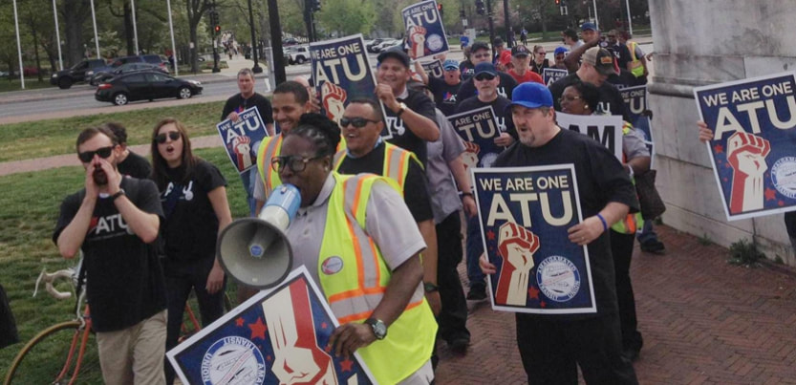
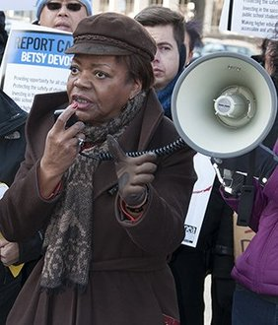
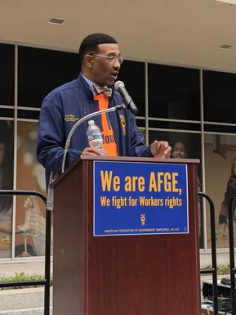
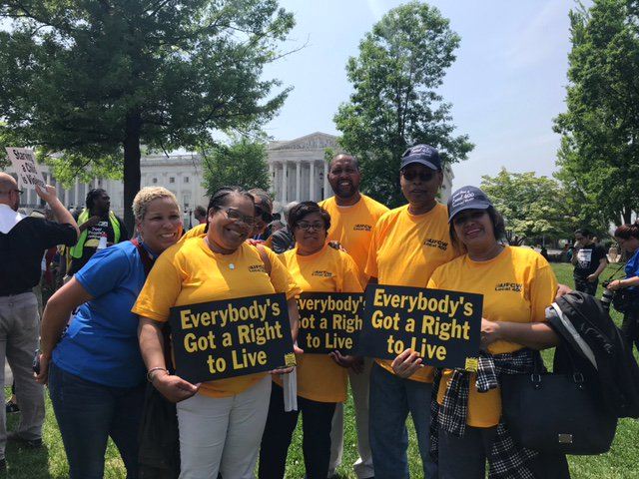
Union City coverage, May 2018
http://www.dclabor.org/home/archives/05-2018
Highlights include:
ONE FAIR WAGE CAMPAIGN URGES “YES ON 77”
COMMUNICATIONS WORKERS SLAM “OUTRAGEOUS” AT&T
NORTON URGES POMPEO TO RECONSIDER STATE DEPT CLEANER LAYOFFS
WHY DCA WORKERS HAVE THE JETBLUES
METRO WASHINGTON COUNCIL AFL-CIO ENDORSES IN DC, MONTGOMERY AND PRINCE GEORGE’S PRIMARIES
BUILDING FUTURES GRADUATE GIVES BACK
CIRCULATOR WORKERS FIND AN ALLY ON DC CITY COUNCIL
RED CROSS UNION COALITION PRESENTS PROPOSALS
PARKS & PLANNING WORKERS RATIFY NEW CONTRACT
KROGER WORKERS DEMAND ANSWERS AT TOWN HALL
HOSPITAL UNION ESCALATES CONTRACT FIGHT AT GWUH
UMD WORKERS TURN UP THE HEAT
DC CANDIDATE QUESTIONNAIRES POSTED
POOR PEOPLE’S CAMPAIGN LAUNCHES TODAY
CLEANING CONTRACTOR BUDGET CUTS CREATE MESS AT STATE DEPT
AFGE NOTCHES DC-AREA ORGANIZING WINS
“SPITFIRE” STEWARD STANDS UP FOR HER MEMBERS
WORKING WOMEN ORGANIZE TO “TAKE BACK OUR COUNTRY”
DC CIRCULATOR WORKERS FACED WITH “DANGEROUS” WORKING CONDITIONS
MARYLAND STATE AND DC AFL-CIO RELEASES PRIMARY ENDORSEMENTS
IBEW 26 MOVING SILVER LINE ALONG
STATE WORKERS PREP FOR CONTRACT ENFORCEMENT
2018 DC LABORFEST LAUNCHES TODAY ON MAY DAY

