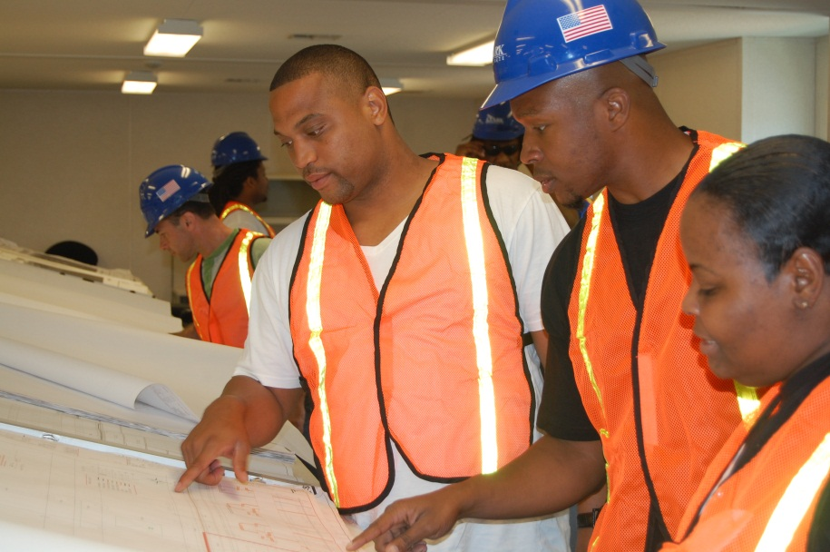
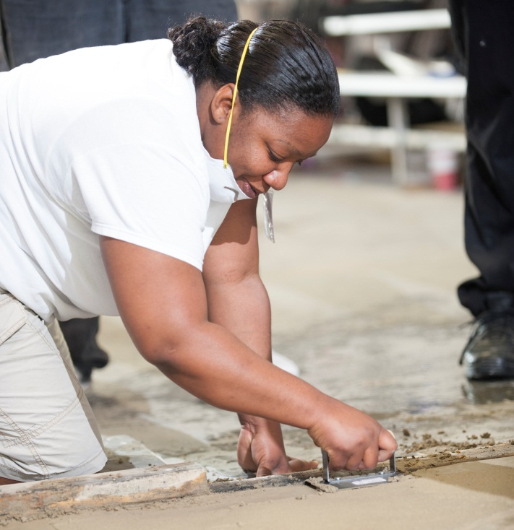

Prepare for Construction and Building Trades Apprenticeships and Jobs

OUR 6-WEEK PRE-APPRENTICESHIP PROGRAM

Prepares You To Become a Better Candidate for Entry
Into Apprenticeships or Occupations Like These:

Insulation ● Heavy Equipment ● Building Maintenance ● Laborers

● Cement Masonry ● Steam fitting ● Bricklaying ● Sheet Metal Work

● Plumbing ● Electrical Systems ● Carpentry ● Ironwork

●Fire & Alarm Systems ● Painting

Become certified in:

OSHA 10

CPR

First Aid and AED

Flagger Safety

To apply you must:
- Want a career in construction
- Be 21 years of age or older
- Be Drug-free & healthy
- Have a high school diploma or GED
- Have a Valid Driver’s license or Learner’s Permit

You will learn about:
- The construction industry
- Tools and materials
- Basic construction math
- Blueprint reading
- Job readiness
- Green Technologies

If you are interested in CONSTRUCTION as a career,
CALL (202) 974-8224/8224
for more information.
Note: Applications to the February class will be accepted until January 20th

