cid:image002.png@01CD927F.DE4AAC30Community Services Agency

of the Metropolitan Washington Council, AFL-CIO

**CSA Annual Program Highlights**“Labor Cares – Labor Shares”

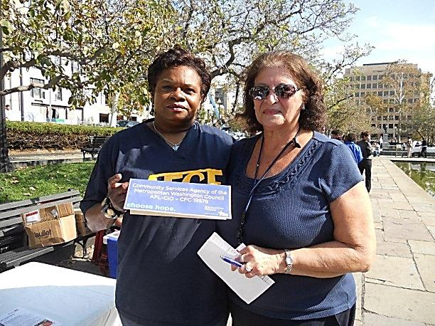AFGE Local 32 supporting CSA at their annual CFC union fair

**Assisting with Emergency Needs**

* **Emergency Assistance Program** helped 400 working families avoid evictions, foreclosures, utility cut-offs and hunger
* **Holiday Basket Project** provided food, gifts and funds for 75 area needy working families at Thanksgiving and Christmas
* **Food Drives** collected non-perishable food distributed to over 100 neighbors in need and other social services agencies
* **Referrals** to area agencies for health care, credit card debt, eldercare problems, domestic violence and suicide prevention for 175 neighbors

|  |
| --- |
| *Every year, CSA sponsors the “Bowling for Gold” Bowling Tournament, Labor Night at the Nats, and the Annual Golf Tournament, all of which raise money for the Emergency Assistance Fund. For information about these fun events, email kmckirchy@dclabor.org* |

**Helping Families Become Economically Independent**

* **Building Futures Program** trained 86 unemployed area residents in a construction pre-apprenticeship training program with 76 landing jobs and apprenticeships after graduation
* **Hospitality Express 4 Success Training Program** provided training and industry-recognized certifications to 33 Prince George’s County, MD youth with job placement in area hotels, convention centers and restaurants
* Conducted **academic and job readiness assessments for over 600** underemployed and unemployed neighbors with referrals for jobs and training
* Provided **Career Educational Workshops** for 50 returning citizens to help them find good jobs in the construction industry

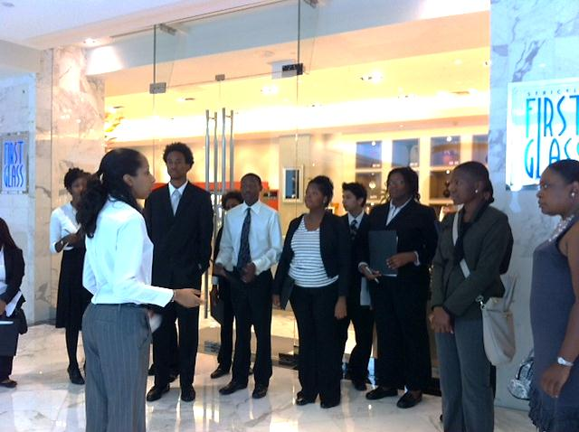

Hospitality students getting a tour at Gaylord National Resort and Convention Center

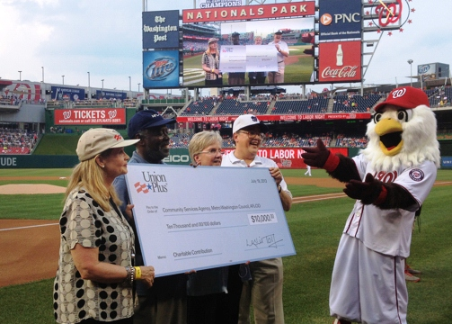**Supporting the Local Labor Community**

* **Letter Carriers Annual Food Drive** on Mother’s Day weekend promoted and supported providing non-perishable food for area food banks
* **Federal worker locals** supported during sequestration and federal government shutdown with financial and other support for members of AFGE locals and AFSCME Council 26 locals
* **Emergency Assistance** provided to 400 members of area local unions
* **Union apprentice graduation ceremony** attendance by staff for **Elevator Constructors Local 10, Sheet Metal Workers Local 100, Electricians Local 26**, and **Iron Workers Local 5**
* Provided information on how to use the agency to members of the **DC Nurses Association**
* Provided **strike support** assistance to **UFCW Local 400**

*Contributions to Labor Night at the Nats help us help workers like you*

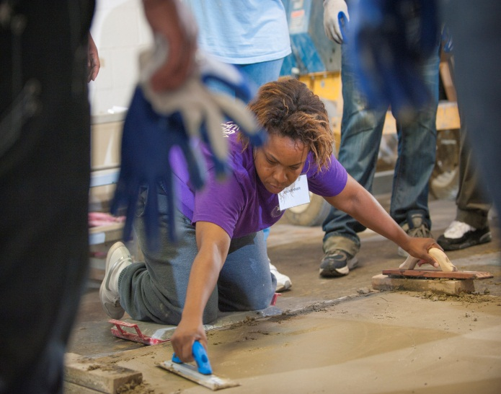The mission of the Community Services Agency is to **improve the lives of workers and their families** by meeting their human and social services’ needs; by building broad and diverse coalitions to promote and protect dignity and justice for workers; and by empowering workers and their unions to make their communities better, more responsive places to live, work, raise a family and retire.

*CSA is a United Way/Combined Federal/DC ONE Fund Campaign Participant and is a member of the DC Jobs Council, the Fair Budget Coalition, the Fairfax County Alliance for Human Services, and the AFL-CIO Community Services Network.*

*CSA provides services for residents of suburban Maryland, Northern Virginia, and the District of Columbia*

**Workers Helping Workers**Many Hands Make a Stronger Community

One of many Building Futures grads now in apprenticeship

**Support the Community Services Agency:**

**United Way** and **DC One Fund** Campaigns: **#8253**

**Combined Federal** **Campaign**: **#19579**

**Maryland Charity** **Campaign**: **#9320**

888 16th Street NW, Suite 520

Washington, DC 20006

202 974-8220

www.dclabor.org  
*click on “Community Services”*